Basic Seed Saving

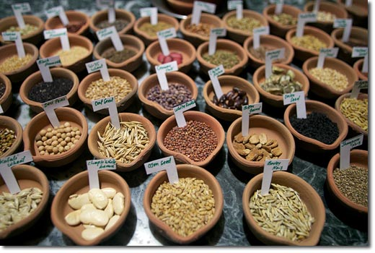

Methods:

- Dry- for peas, beans, lettuce, or any seed that is mature when the mother plant is dying or drying up.

- Wet- for seeds that are inside the fruit and are set in a liquid, stringy, or gelatinous substance.

- Fermentation- for tomatoes, because the gel around the seeds inhibits germination.

Collection of seeds from flowers varies between each type, but seeds can generally be found where the flower was after the flower is gone.

Dry Seeds

To collect seeds from these plants (peas, beans, etc.), wait for the pod to be dry and brown. Then open the pod and remove the seeds. To make sure the seeds are ready, try to dent one with your fingernail; if it gets a mark, it isn’t ready yet.

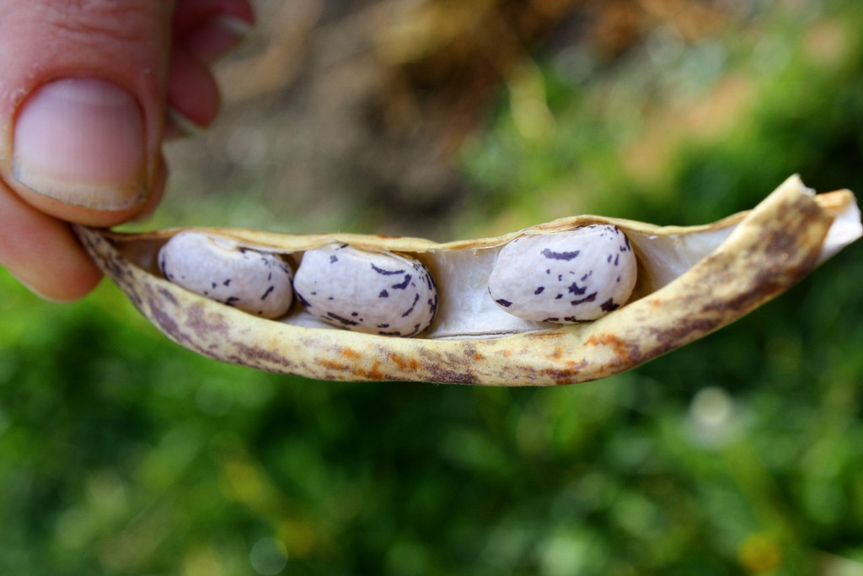

Wet Seeds

To collect seeds from these plants, collect the mature fruit or vegetable. Cut it open, scoop out the seeds, and then wash them off. Let them dry on a non-porous surface (glass, metal, plastic, etc.).

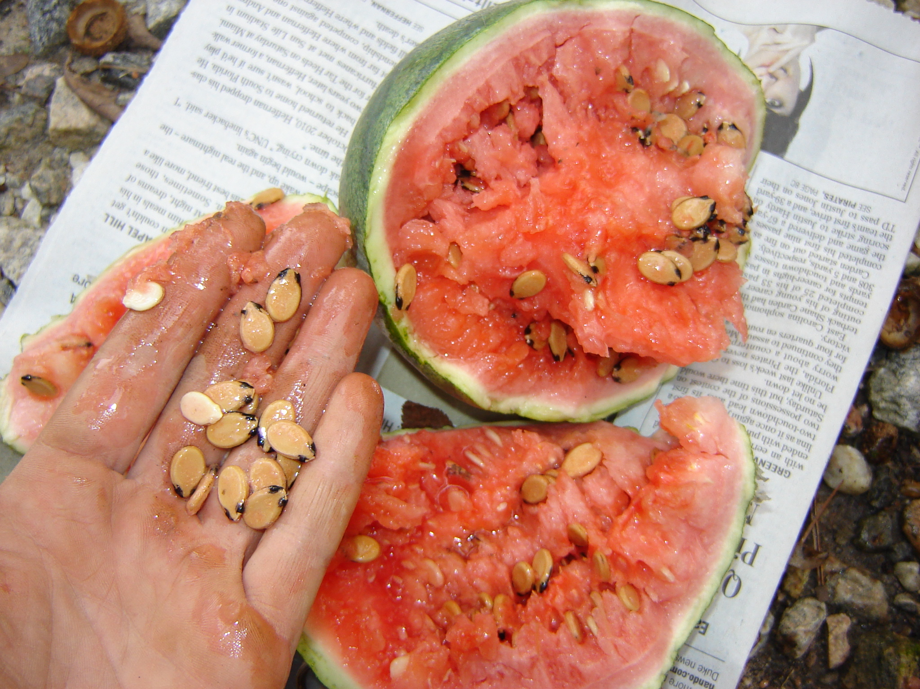

Fermentation

This is for tomatoes. Cut the tomato in half at the equator, exposing the seeds, and squeeze out the jelly-like substance that contains the seeds. Place the jelly in a small jar (add a little water if you’re only using one or two tomatoes), and cover the container. Place in a room temperature location for about three days.

A layer of fungus will being to form at the top of the mixture after a couple days. This fungus eats away the germination-inhibiting coat on the seeds, and helps control seed-borne diseases. Watch the seeds closely- if left in the water too long, they will begin to germinate and cannot then be saved. If they have begun to swell or grown tiny roots, they can still be planted, just not saved.

After about three days, fill the container with warm water and let settle. Viable seeds will sink, while immature seeds will float. Drain out the water and anything that is floating. Repeat until the water being poured out is almost clear and clean seeds line the bottom of the container. Pour these seeds into a strainer with holes smaller than the seeds, let the excess water drip out, and empty the seeds onto a non-porous surface to dry. Seeds should dry completely in one to three days.
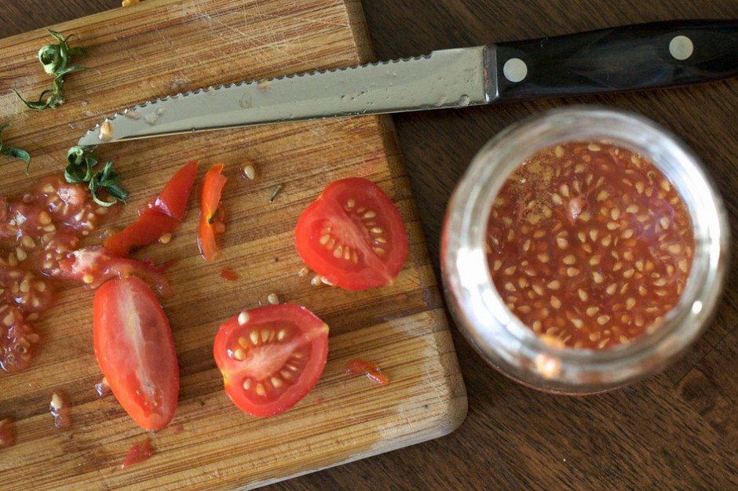

Pollination

Seeds can only be saved from plants that are open pollinated. Cross-pollinated plants (e.g. hybrids) cannot be saved because the seed will not breed true.

All the plants discussed here are self-pollinated, which means that the flowers contain both the male and female parts. Cross-pollination generally does not occur with these plants, but different varieties of these plants should still be kept separate.

Easy Vegetables for Seed Saving
Bean - Phaseolus vulgaris
PLANT: Although, ideally, different varieties should be separated by 150 feet or another crop flowering at the same time, we rarely observe cross-pollination even when two varieties are grown next to each other.
FLOWER: Beans produce perfect, self-pollinating flowers. Cross pollination by insects is possible but rare as pollination occurs before the flower opens. Because the anthers are pushed up against the stigma, automatic pollination is assured when the anthers open.
HARVEST: Allow pods to dry brown before harvesting, about six weeks after eating stage. If frost threatens, pull entire plant, root first, and hang in cool, dry location until pods are brown.
PROCESS: Small amounts of pods can be opened by hand. Flail larger amounts. Remove large chaff by hand or fork. Winnow remaining particles.
Peas - Pisum sativum
PLANT: Ideally, different varieties need to be separated 50 feet or with another crop flowering at the same time. However, in the cool regions of the Rocky Moun tains, we rarely observe cross-pollination even when two varieties are grown next to each other.
FLOWER: Peas produce perfect, self-pollinating flowers. Cross-pollination by insects is possible but rare because pollination occurs before the flower opens. Because the stigma does open before pollen is ready crosses theoretically could occur.
HARVEST: Allow pods to dry brown before harvesting, about four weeks after eating stage. If frost threatens, pull entire plant, root first, and hang in cool, dry location until pods are brown.
PROCESS: Small amounts of pods can be opened by hand. Flail larger amounts. Remove large chaff by hand or fork. Winnow remaining particles.
Tomato - Lycopersicon esculentum
PLANT: Separate varieties with short styles (most modern varieties) by at least 10 feet. Varieties with long styles (heirlooms and older varieties) need at least 100 feet to ensure purity. If solitary bees are prevalent, separate all varieties at least 100 feet and place another flowering crop between.
FLOWER: Tomatoes produce perfect, self-pollinating flowers. Anthers are fused together into a little cone that rarely opens until pollen has been shed and the stigma pollinated. (Older varieties with wild tomatoes or L. pimpinellifolium in their genetic ancestry may have stigmas that stick out beyond the cone containing the anthers. Varieties with this trait can be identified by looking closely at mature flowers and need to be treated accordingly.)
HARVEST: If possible, allow tomatoes to completely ripen before harvesting for seed production. Unripe fruits, saved from the first frost, will ripen slowly if kept in a cool, dry location. Seeds from green, unripe fruits will be most viable if extracted after allowing the fruits to turn color.
PROCESS: Fermentation.
Lettuce - Lactuca sativa
PLANT: Separate varieties flowering at the same time by at least 20 feet to ensure purity.
FLOWER: Lettuce produces perfect, self-pollinating flowers. Each flower produces one seed. Flowers are grouped in little heads of 10-25 flowers all of which open at once for as little as 30 minutes. Anthers are fused together into a little cone that completely surrounds stigma and style. Style is pushed up through anther cone and is coated with its own pollen. Note: Mature head lettuce may need a slit (two or three inches deep) across the top to encourage flowering.
HARVEST: Some outside leaves can be harvested for eating without harming seed production. Allow seed heads to dry 2-3 weeks after flowering. Individual heads will ripen at different times making the harvest of large amounts of seed at one time nearly impossible. Wait until half the flowers on each plant has gone to seed. Cut entire top of plant and allow to dry upside down in an open paper bag.
PROCESS: Small amounts of seed can be shaken daily from individual flowering heads. Rub with hands to remove remaining seeds. If necessary, separate seeds from chaff with screens.
Pepper - Capsicum annuum
PLANT: Most home gardeners will get satisfactory results if different varieties are separated by 50 feet and another tall, flowering crop. New studies from New Mexico State University show more crossing than was previously thought. We recommend at least 400 feet between varieties to ensure absolute purity.
FLOWER: Peppers produce perfect, mostly self-pollinating flowers. Solitary bees will pollinate if a more desirable pollen is not available in the area.
HARVEST: Harvest mature, fully-ripe peppers for seed. (Most bell peppers turn red when fully mature.) If frost threatens before peppers mature, pull entire plant and hang in cool, dry location until peppers mature.
PROCESS: There are two methods, dry and wet, to process pepper seeds. The dry method is adequate for small amounts. Cut the bottom off the fruit and carefully reach in to strip the seeds surrounding central cone. In many cases, seeds need no further cleaning. To process the seed from large amounts of peppers, cut off the tops just under the stem, fill a blender with peppers and water and carefully blend until good seeds are separated and sink to bottom. Pepper debris and immature seeds will float to the top where they can be rinsed away. Spread clean seeds on paper towel and dry in cool location until seed is dry enough to break when folded.
Determining Seed Maturity

Beans & Peas: Pods should be brown, dry, and brittle before harvest, and the seeds should be very hard (use the fingernail test).
Lettuce: Two or three weeks after the lettuce flowers have opened, the seeds should be mature. Look for feathery parachute-like structures (think dandelions) before harvesting.
Tomatoes: The seeds are ready when the tomato is ready to be eaten.
Peppers: Seeds are ready when the pepper fruit has matured to its final color.

Storing Seeds

Most seeds will remain shelf stable for a year as long as they are protected from:
- Heat
- Moisture
- Light
This prevents them from germinating before you’re ready.
Seeds can be stored in Ziploc bags, or anything airtight that will keep them moisture-free. It’s also helpful to label the container with the plant name, variety, and date of harvest.
The information we request for donations to the Westford Seed Library:
- Common Name
- Variety
- Year of Harvest
- Harvest Neighborhood (town grown in)
- Harvester
- Organic/Heirloom (Y or N)
- Any Notes

Further Information
- www.seedsavers.org
- www.howtosaveseeds.com
- www.seedsave.org

